**Learner Details**

* **Name:Nikhil k**
* **Enrollment Number: su625mr004**
* **Batch / Class: Mern Stack**
* **Assignment: Product card**
* **Date of Submission: 30-07-2025**

**Problem Solving Activity 1.1**

**1. Program Statement**

To create a simple React component that displays a product card with an image, product name, price, and key specifications. The component should use inline styling and flex layout to achieve a clean UI.

**2. Algorithm**

• Start the React application.

• Create a functional component named Card.

• Display a heading at the top.

• Use JSX to render a product card that includes:

* Product image
* Product title
* Price
* Specifications

• Use inline styles to define layout and appearance.

• Export the component and render it in the main application.

**3. Pseudocode**

START

Create component Card

Display a heading "Product card"

Use flex container to center card

Display product card:

- Image

- Title

- Price

- Specs

Apply inline styles:

Card container: flexbox

Card: border, background, padding

Image: rounded, fixed size

END

**4. Program Code**

import React from 'react'

const Card = () => {

return (

<div style={{ padding: '2rem', fontFamily: 'sans-serif', backgroundColor: '#000000ff' }}>

<h1 style={{ textAlign: 'center', color: '#fff' }}>Product card</h1>

<div style={{

display: 'flex',

flexWrap: 'wrap',

gap: '1.5rem',

justifyContent: 'center',

marginTop: '2rem'

}}>

<div style={cardStyle}>

<img

src="https://upload.wikimedia.org/wikipedia/commons/thumb/9/99/LEI0440_Leica_IIIf_chrom_-_Sn._580566_1951-52-M39_Blitzsynchron_front_view-6531_hf-.jpg/960px-LEI0440_Leica_IIIf_chrom_-_Sn._580566_1951-52-M39_Blitzsynchron_front_view-6531_hf-.jpg"

style={imgStyle}

/>

<h2>Camera</h2>

<p><strong>Price:</strong> Rs. 4599/-</p>

<p><strong>UHD 5cm 1:35</strong></p>

<p>22x zoom</p>

<p>Mega Flash</p>

</div>

</div>

</div>

);

};

const cardStyle = {

border: '5px solid #000',

borderRadius: '2px',

padding: '1rem',

width: '300px',

backgroundColor: '#9affffff',

color: '#000',

textAlign: 'center'

};

const imgStyle = {

width: '90%',

height: '200px',

objectFit: 'cover',

borderRadius: '6px',

marginBottom: '1rem'

};

export default Card;

**5. Test Cases**

| **Test Case** | **Input/Action** | **Expected Output** |  |
| --- | --- | --- | --- |
| **Check layout rendering** | **Load component** | **Product card centered on screen** |  |
| **Check image display** | **Image URL provided** | **Image shown with proper size/style** |  |
| **Check product details** | **Static data used** | **Title, price, and specs shown** |  |
| **Styling check** | **View in browser** | **Border, padding, background apply** |  |

**6. Screenshots of Output**

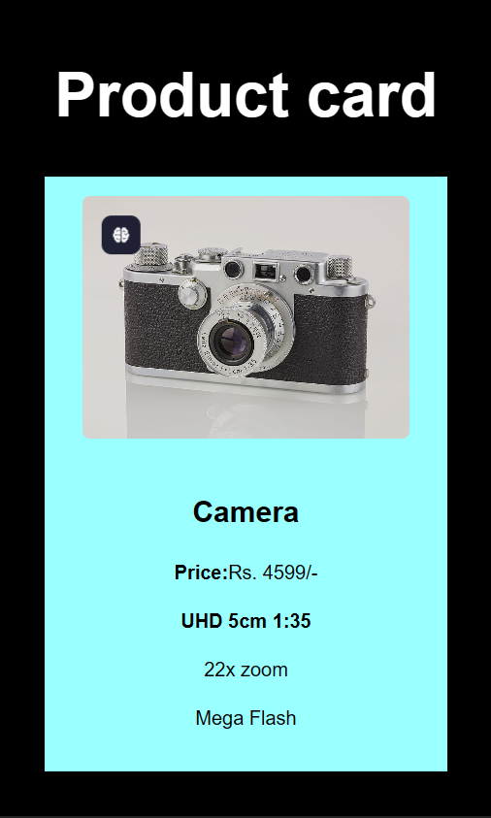

**7. Observation / Reflection**

• The project helped understand how to use inline styles in React.

• Flexbox made it easy to align and center the card.

• Image rendering and styling gave insight into responsive design basics.

• This card can be reused for other products or expanded into a full product catalog in the future.

**Problem Solving Activity 1.2**

**Follow the same Structure as problem Solving Activity 1.1.**